Supplementary File 2: ZEN software steps for SHG image acquisition

 | Description | Icon in ZEN software | Notes:
1 | In Light Path: Select the Non Descanned imaging mode. The transmission path corresponds to the bottom part of the diagram. Tick below the desired detection filter symbol, in this case SP485.  Main beam splitter for invisible light: select MBS 760+  Reflector revolver: select Rear. | 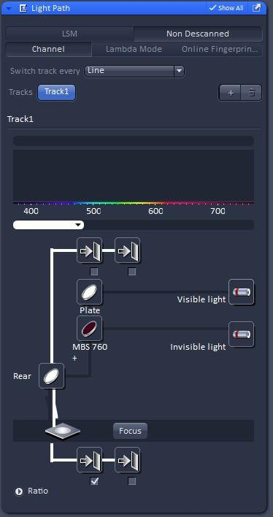 | This way the capture of the weak SH signal of tubulin will be optimized.
2 | Turn on the laser in the software from Laser:  Chameleon, select On | 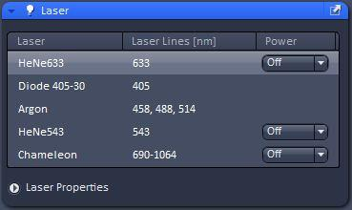 | This will open the shutter. NOTE: Make sure the laser was previously turned on from the pump laser module
3 | In Channels, select the chameleon wavelength to 810 nm. Select 10% to 20% chameleon laser power in the software | 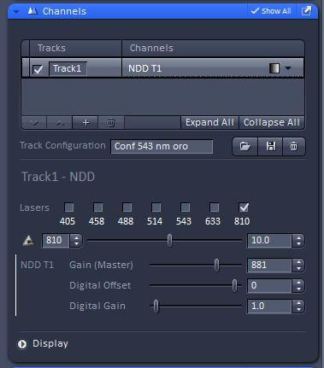 | In the system described, this corresponds to 13 to 26 mW measured at objective BFP
4 | In Acquisition Mode, select imaging speed 5, which corresponds to pixel dwell times of 12.6 us | 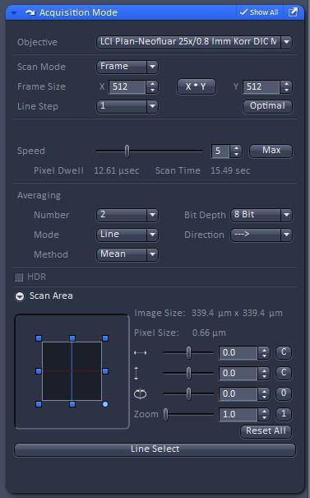 | Total acquisition time will be defined only after selecting averaging (step 5)
5 | Select averaging 2 |  | With these settings, this will determine a total image time of about 15 sec.
6 | Select 25x objective from the software |  | Oil should be added to the objective lens before selecting the objective, if the sample is already in place. The objective can be selected in alternative ways.
7 | Use the Live mode for the initial visualization. Adjust acquisition parameters (gain, offset) with the Continuous mode. | 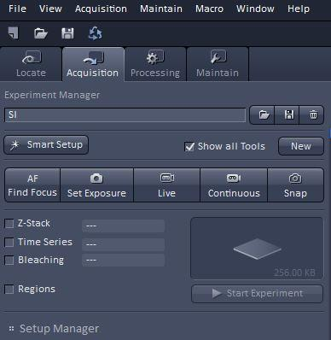 | Live reduces exposition
8 | When ready, take an image with Snap
9 | Repeat imaging (step 8) with bandpass filter inserted |  | This will clean the image from any autofluorescence

